DAY 1: ______________________________________________

Homeroom:
1 | 1201 A
2 | 3201 B
Recess:
3 | 3201 C
Lunch:
4 | 2201 D
5 | PREP E
After School & Notes:

DAY 2: ______________________________________________

Homeroom:
1 | 1201 F
2 | 2201 G
Recess:
3 | 1201 A
Lunch:
4 | 3201 B
5 | 3201 C
After School & Notes:

DAY 3: ______________________________________________

Homeroom:
1 | 2201 D
2 | PREP E
Recess:
3 | 1201 F
Lunch:
4 | 2201 G
5 | 1201 A
After School & Notes:

DAY 4: ______________________________________________

Homeroom:
1 | 3201 B
2 | 3201 C
Recess:
3 | 2201 D
Lunch:
4 | PREP E
5 | 1201 F
After School & Notes:

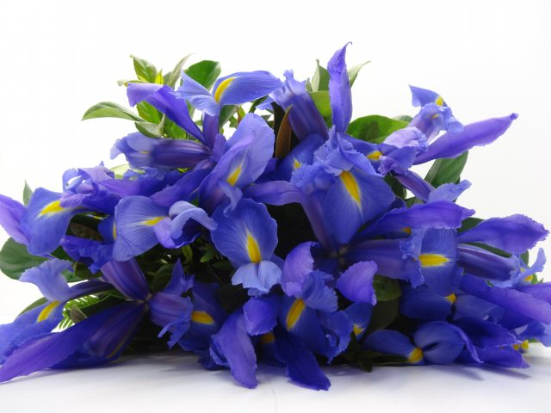 DAY 5: ______________________________________________

Homeroom:
1 | 2201 G
2 | 1201 A
Recess:
3 | 3201 B
Lunch:
4 | 3201 C
5 | 2201 D
After School & Notes:

DAY 6: ______________________________________________

Homeroom:
1 | PREP E
2 | 1201 F
Recess:
3 | 2201 G
Lunch:
4 | 1201 A
5 | 3201 B
After School & Notes:

DAY 7: ______________________________________________

Homeroom:
1 | 3201 C
2 | 2201 D
Recess:
3 | PREP E
Lunch:
4 | 1201 F
5 | 2201 G
After School & Notes::
sCHEDULE
Day  Period | 1 | 2 | 3 | 4 | 5 | 6 | 7
HOMEROOM
1 | 1201 A | 1201 F | 2201 D | 3201 B | 2201 G | PREP E | 3201 C
2 | 3201 B | 2201 G | PREP E | 3201 C | 1201 A | 1201 F | 2201 D
RECESS
3 | 3201 C | 1201 A | 1201 F | 2201 D | 3201 B | 2201 G | PREP E
LUNCH
4 | 2201 D | 3201 B | 2201 G | PREP E | 3201 C | 1201 A | 1201 F
5 | PREP E | 3201 C | 1201 A | 1201 F | 2201 D | 3201 B | 2201 G

1201 Days in Common |  |  |  |  | Class Meeting Times  1201 A Day 1, p1 Day 2, p3 Day 3, p5 Day 5, p2 Day 6, p4  1201 F Day 2, p1 Day 3, p3 Day 4, p5 Day 6, p2 Day 7, p4  2201 D Day 1, p4 Day 3, p1 Day 4, p3 Day 5, p5 Day 7, p2  2201 G Day 2, p2 Day 3, p4 Day 5, p1 Day 6, p3 Day 7, p5  3201 B Day 1, p2 Day 2, p4 Day 4, p1 Day 5, p3 Day 6, p5  3201 C Day 1, p3 Day 2, p5 Day 4, p2 Day 5, p4 Day 7, p1  PREP E Day 1, p5 Day 3, p2 Day 4, p4 Day 6, p1 Day 7, p3
Day 2: | 1201 F: | Day 2, p 1 | 1201 A: | Day 2, p 3
Day 3: | 1201 F: | Day 3, p 3 | 1201 A: | Day 3, p 5
Day 6: | 1201 F: | Day 6, p 2 | 1201 A: | Day 6, p 4
2201 Days in Common
Day 3: | 2201 D: | Day 3, p 1 | 2201 G: | Day 3, p 4
Day 5: | 2201 G: | Day 5, p 1 | 2201 D: | Day 5, p 5
Day 7: | 2201 D: | Day 7, p 2 | 2201 G: | Day 7, p 5
3201 Days in Common
Day 1: | 3201 B: | Day 1, p 2 | 3201 C: | Day 1, p 3
Day 2: | 3201 B: | Day 2, p 4 | 3201 C: | Day 2, p 5
Day 4: | 3201 B: | Day 4, p 1 | 3201 C: | Day 4, p 2
Day 5 | 3201 B: | Day 5, p 3 | 3201 C: | Day 5, p 4

